# Q.1) Write a Python program to print all even numbers from a given list
# of numbers in the same order. Stop printing if any number that comes after 237 in the sequence is encountered.
# Sample
# numbers list :
# numbers = [ 386, 462, 47, 418, 907, 344, 236, 375, 823, 566, 597, 978, 328, 615, 953,
# 345, 399, 162, 758, 219, 237, 412, 566, 731, 210, 912, 216, 244, 896, 101, 867, 355, 430 ]
# expected output:
# 386 462 418 344 236 566 978 328 162 758
numbers = [ 386, 462, 47, 418, 907, 344, 236, 375, 823, 566, 597, 978, 328, 615, 953, 345, 399, 162, 758, 219, 237, 412, 566, 731, 210, 912, 216, 244, 896, 101, 867, 355, 430 ]
for num in numbers:
if num % 2 == 0:
print(num, "is even")
if num == 237:
break

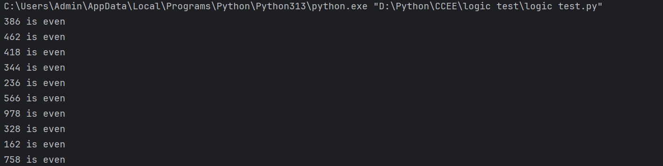

Q.2) Write a python program to get the path and name of the file that is currently executing
import os
print("File name:", os.path.basename(__file__))
print("File path:", os.path.abspath(__file__))
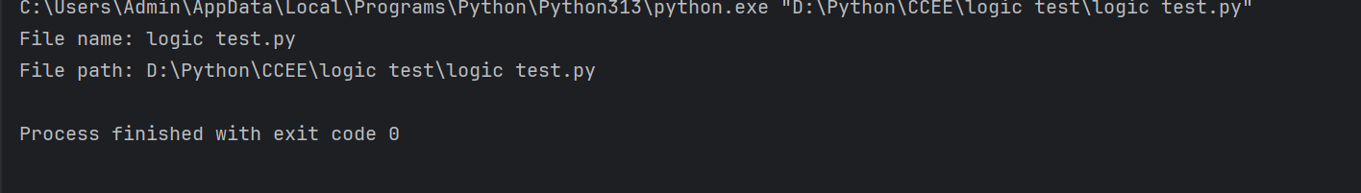
# Q.3) pattern
# 1
# 212
# 32123
# 4321234
# 543212345
for i in range(1,6):
for o in range(5-i,0,-1):
print(" ", end="")
for j in range(i,0,-1):
print(j, end="")
for k in range(2,i+1):
print(k, end="")
print()
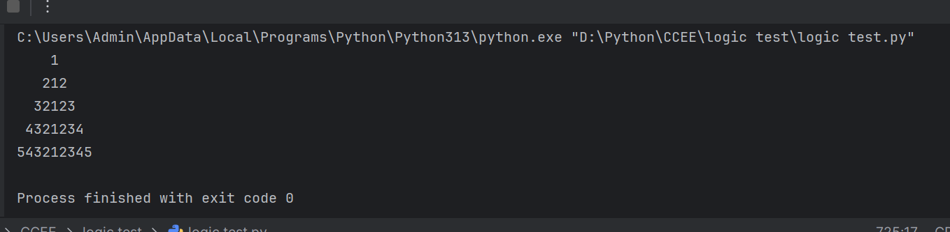
Q.4) Write a code to accept a number & print its digits in words .
Ex: 321
Three
Two
One
num = input("enter a number: ")
words = {
'0': "zero",
'1': "one",
'2': "two",
'3': "three",
'4': "four",
'5': "five",
'6': "six",
'7': "seven",
'8': "eight",
'9': "nine"
}
for digit in num:
print(words[digit])

